**1. Data Scenarios and Optimal Parameters to Predict the Heat load**

The process of model optimization to predict the heat load was carried out by evaluating the effect of including various type of input parameters. In this context three different data scenarios have been created to each model in winter and shoulder terms.

**1.1 Models with Optimal Lagged Heat Load Variables (1st Data Scenario)**

**Table 1. Evaluation metrics with the inclusion depth lagged heat values (winter term). The optimal parameters are highlighted in green**

|  |  |  |  |  |  |  |  |  |  |
| --- | --- | --- | --- | --- | --- | --- | --- | --- | --- |
| **Winter term** | | | | | | | | | |
| **Lagged Heat Load variables** | **Workdays model** | | | | **Lagged Heat Load variables** | **Weekends model** | | | |
| **Adj R-squared** | **AIC** | **BIC** | **MAE** | **Adj R-squared** | **AIC** | **BIC** | **MAE** |
| POWER1_lag1 | 0.728 | 3862 | 3871 | 2.092 | POWER1_lag1 | 0.646 | 1490 | 1498 | 2.146 |
| POWER1_lag2 | 0.782 | 3695 | 3709 | 1.911 | POWER1_lag2 | 0.695 | 1447 | 1458 | 1.999 |
| POWER1_lag3 | 0.797 | 3640 | 3658 | 1.837 | POWER1_lag3 | 0.710 | 1432 | 1447 | 1.954 |
| POWER1_lag4 | 0.797 | 3639 | 3663 | 1.838 | POWER1_lag4 | 0.716 | 1427 | 1446 | 1.968 |
| POWER1_lag5 | 0.799 | 3633 | 3661 | 1.823 | POWER1_lag5 | 0.719 | 1425 | 1447 | 1.962 |
| POWER1_lag6 | 0.799 | 3634 | 3666 | 1.822 | POWER1_lag6 | 0.727 | 1417 | 1443 | 1.911 |
| POWER1_lag7 | 0.800 | 3634 | 3671 | 1.827 | POWER1_lag7 | 0.729 | 1416 | 1445 | 1.892 |
| POWER1_lag8 | 0.801 | 3630 | 3672 | 1.822 | POWER1_lag8 | 0.728 | 1418 | 1451 | 1.892 |
| POWER1_lag9 | 0.800 | 3632 | 3679 | 1.822 | POWER1_lag9 | 0.728 | 1419 | 1457 | 1.892 |
| POWER1_lag10 | 0.801 | 3631 | 3682 | 1.814 | POWER1_lag10 | 0.727 | 1421 | 1462 | 1.889 |
| POWER1_lag11 | 0.804 | 3622 | 3678 | 1.802 | POWER1_lag11 | 0.735 | 1413 | 1457 | 1.877 |
| POWER1_lag12 | 0.804 | 3622 | 3682 | 1,800 | POWER1_lag12 | 0.734 | 1415 | 1463 | 1.875 |

**Table 2. Evaluation metrics with the inclusion depth lagged heat values (shoulder term)**

|  |  |  |  |  |  |  |  |  |  |
| --- | --- | --- | --- | --- | --- | --- | --- | --- | --- |
| **Lagged Heat Load variables** | **Workdays model** | | | | **Lagged Heat Load variables** | **Weekends model** | | | |
| **Adj R-squared** | **AIC** | **BIC** | **MAE** | **Adj R-squared** | **AIC** | **BIC** | **MAE** |
| POWER1_lag1 | 0.837 | 7366 | 7382 | 1.947 | POWER1_lag1 | 0.784 | 3000 | 3009 | 1.951 |
| POWER1_lag2 | 0.837 | 7366 | 7382 | 1.824 | POWER1_lag2 | 0.810 | 2921 | 2935 | 1.831 |
| POWER1_lag3 | 0.838 | 7355 | 7377 | 1.812 | POWER1_lag3 | 0.816 | 2902 | 2919 | 1.795 |
| POWER1_lag4 | 0.838 | 7357 | 7384 | 1.812 | POWER1_lag4 | 0.816 | 2904 | 2926 | 1.795 |
| POWER1_lag5 | 0.838 | 7359 | 7391 | 1.811 | POWER1_lag5 | 0.815 | 2907 | 2938 | 1.795 |
| POWER1_lag6 | 0.838 | 7360 | 7398 | 1.810 | POWER1_lag6 | 0.815 | 2907 | 2938 | 1.795 |
| POWER1_lag7 | 0.838 | 7357 | 7400 | 1.812 | POWER1_lag7 | 0.816 | 2905 | 2940 | 1.792 |
| POWER1_lag8 | 0.838 | 7356 | 7404 | 1.815 | POWER1_lag8 | 0.816 | 2906 | 2945 | 1.789 |
| POWER1_lag9 | 0.838 | 7357 | 7411 | 1.816 | POWER1_lag9 | 0.816 | 2907 | 2952 | 1.790 |
| POWER1_lag10 | 0.838 | 7358 | 7417 | 1.817 | POWER1_lag10 | 0.817 | 2907 | 2960 | 1.785 |
| POWER1_lag11 | 0.839 | 7354 | 7418 | 1.815 | POWER1_lag11 | 0.817 | 2907 | 2960 | 1.787 |
| POWER1_lag12 | 0.840 | 7347 | 7417 | 1.813 | POWER1_lag12 | 0.817 | 2907 | 2964 | 1.792 |

**1.2 Models with Optimal Lagged Weather Variables (2nd Data Scenario)**

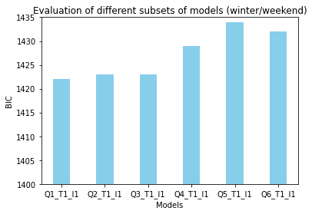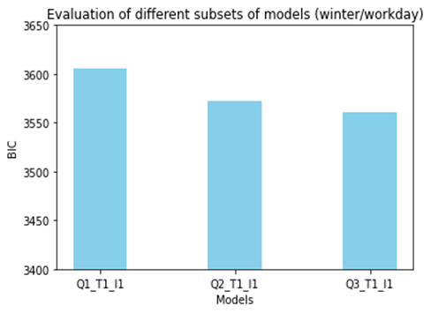***Selection of The Best Subset of Lagged Temperature and Irradiation Flux Variables***

**(a) (b)**

**Figure 1. Evaluation of different subsets of models in winter terms: (a) workday model, (b) weekend model**

The evaluation of different subsets of models in winter for both workdays and weekends were illustrated in fig 1 above.

The lowest BIC score was represented by the Q3_T1_I1. Thus, this model was selected for the workdays model in winter term. On the weekends, the BIC of the Q1_T1_I1 model is lower than Q2_T1_I1 and Q3_T1_I1 which are equivalent. Thus, we have selected this model (Q_T1_I1) since it is simpler than the two other models and incorporate less variables.

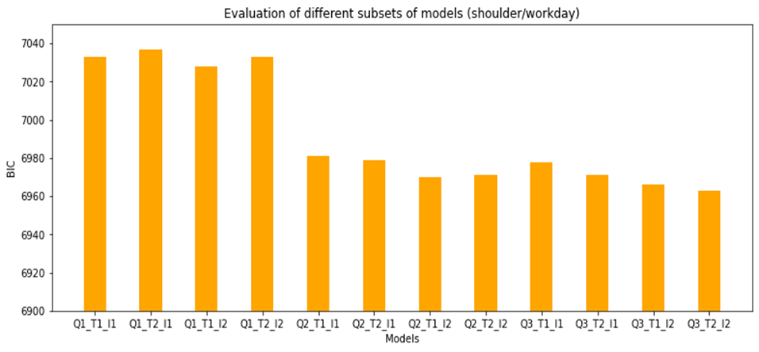

**Figure 2. Evaluation of different subsets of models in shoulder season (workday)**

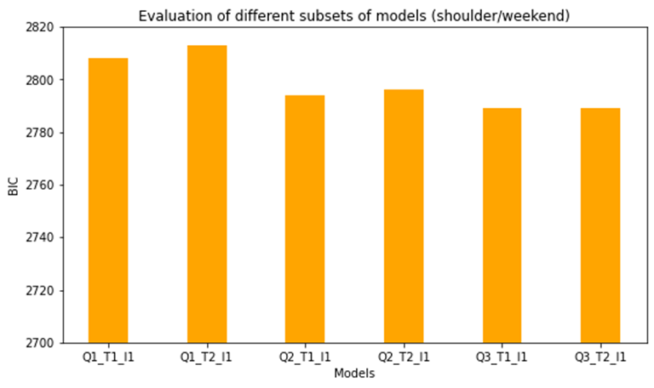

**Figure 3. Evaluation of different subsets of models in shoulder season (weekend)**

The evaluation of different subsets of models in shoulder term for both workdays and weekends were illustrated in fig 2 and fig 3 above.

On workdays the Q3_T2_I2 model was selected since it represents the lowest value of BIC (6963). On weekends Q3_T1_I1 and Q3_T2_I1 showed the best score, however, we chose only Q3_T1_I1 model since it has the smaller number of variables.

**1.3 Models with Significant Calendar Data. (3rd Data Scenario)**

**Table 3. Evaluation metrics with the significant calendar data variables (winter terms / workdays). The bold values represent the significant variables to enter.**

|  |  |  |  |  |  |  |  |  |
| --- | --- | --- | --- | --- | --- | --- | --- | --- |
| **Winter term / workdays** | | | | | | | | |
| **Variables to enter** | | | | | | **Evaluation metrics** | | |
| **Tuesday1h** | **Wednesday 3h** | **Wednesday 7h** | **Friday 5h** | **Friday 16h** | **Monday 8h** | **Adj R-squared** | **AIC** | **BIC** |
| × |  |  |  |  |  | 0.829 | 3493 | 3535 |
| × | × |  |  |  |  | 0.830 | 3490 | 3537 |
| × | × | × |  |  |  | 0.831 | 3488 | 3539 |
| × | × | × | × |  |  | 0.832 | 3485 | 3541 |
| × | × | × | × | × |  | 0.833 | 3482 | 3542 |
| × | × | × | × | × | × | 0.833 | 3482 | 3542 |
|  | × |  |  |  |  | 0.829 | 3494 | 3536 |
|  |  | × |  |  |  | 0.829 | 3494 | 3536 |
|  |  | × | × |  |  | 0.830 | 3490 | 3537 |
|  |  |  | × |  |  | 0.829 | 3495 | 3537 |
| × |  |  | × |  |  | 0.830 | 3491 | 3537 |
| × | × |  | × |  |  | 0.831 | 3488 | 3539 |
|  |  |  |  | × |  | 0.829 | 3493 | 3535 |
| × |  |  |  | × |  | 0.830 | 3489 | 3536 |
| × | × |  |  | × |  | 0.831 | 3487 | 3538 |
| × | × | × |  | × |  | 0.832 | 3484 | 3540 |
|  |  |  |  |  | × | 0.830 | 3491 | 3528 |
| × |  |  |  |  | × | 0.831 | 3487 | 3528 |
| × | × |  |  |  | × | 0.832 | 3484 | 3530 |
| × | × | × |  |  | × | **0.833** | **3481** | **3532** |
| × | × | × | × |  | × | 0.833 | 3479 | 3535 |

**Table 4. Evaluation metrics with significant calendar data variables (winter term / weekends)**

|  |  |  |  |  |  |  |  |
| --- | --- | --- | --- | --- | --- | --- | --- |
| **Winter term / weekend** | | | | | | | |
| **Variables to enter** | | | | | **Evaluation metrics** | | |
| **Saturday 2h** | **Saturday 10h** | **Sunday 1h** | **Sunday 4h** | **Sunday 5h** | **Adj R-squared** | **AIC** | **BIC** |
| × |  |  |  |  | 0.690 | 1479 | 1505 |
| × | × |  |  |  | 0.701 | 1469 | 1499 |
| × | × | × |  |  | 0.705 | 1465 | 1499 |
| × | × | × | × |  | 0.711 | 1459 | 1496 |
| × | × | × | × | × | **0.716** | **1455** | **1496** |
|  | × |  |  |  | 0.696 | 1472 | 1498 |
|  |  | × |  |  | 0.690 | 1479 | 1505 |
| × |  | × |  |  | 0.694 | 1475 | 1505 |
|  |  |  | × |  | 0.692 | 1477 | 1503 |
| × |  |  | × |  | 0.697 | 1473 | 1503 |
| × | × |  | × |  | 0.707 | 1463 | 1497 |
|  |  |  |  | × | 0.689 | 1479 | 1505 |
| × |  |  |  | × | 0.694 | 1476 | 1506 |
| × | × |  |  | × | 0.704 | 1466 | 1500 |
| × | × | × |  | × | 0.708 | 1462 | 1500 |

**Table 5. Evaluation metrics with significant calendar data variables (shoulder / workdays)**

|  |  |  |  |  |  |  |  |  |  |  |
| --- | --- | --- | --- | --- | --- | --- | --- | --- | --- | --- |
| **Shoulder months / workdays** | | | | | | | | | | |
| **Variables to enter** | | | | | | | | **Evaluation metrics** | | |
| **Thursday 2h** | **Friday 7h** | **Friday 10h** | **Friday 11h** | **Friday 21h** | **Monday 0h** | **Monday 1h** | **Monday 8h** | **Adj R-squared** | **AIC** | **BIC** |
| × |  |  |  |  |  |  |  | 0.880 | 7099 | 7158 |
| × | × |  |  |  |  |  |  | 0.880 | 7097 | 7161 |
| × | × | × |  |  |  |  |  | 0.881 | 7089 | 7159 |
| × | × | × | × |  |  |  |  | 0.881 | 7086 | 7161 |
| × | × | × | × | × |  |  |  | 0.881 | 7083 | 7164 |
| × | × | × | × | × | × |  |  | 0.882 | 7079 | 7165 |
| × | × | × | × | × | × | × |  | 0.882 | 7076 | 7168 |
| × | × | × | × | × | × | × | × | **0.882** | **7070** | **7167** |
|  | × |  |  |  |  |  |  | 0.880 | 7099 | 7159 |
|  |  | × |  |  |  |  |  | 0.880 | 7094 | 7153 |
| × |  | × |  |  |  |  |  | 0.880 | 7091 | 7156 |
|  |  |  | × |  |  |  |  | 0.880 | 7098 | 7158 |
| × |  |  | × |  |  |  |  | 0.880 | 7096 | 7160 |
| × | × |  | × |  |  |  |  | 0.880 | 7094 | 7164 |
|  |  |  |  | × |  |  |  | 0.880 | 7099 | 7158 |
| × |  |  |  | × |  |  |  | 0.880 | 7096 | 7161 |
| × | × |  |  | × |  |  |  | 0.880 | 7094 | 7164 |
| × | × | × |  | × |  |  |  | 0.881 | 7087 | 7162 |
|  |  |  |  |  | × |  |  | 0.880 | 7098 | 7157 |
| × |  |  |  |  | × |  |  | 0.880 | 7095 | 7159 |
| × | × |  |  |  | × |  |  | 0.880 | 7093 | 7163 |
| × | × | × |  |  | × |  |  | 0.881 | 7085 | 7160 |
| × | × | × | × |  | × |  |  | 0.881 | 7082 | 7162 |
|  |  |  |  |  |  | × |  | 0.880 | 7099 | 7158 |
| × |  |  |  |  |  | × |  | 0.880 | 7096 | 7160 |
| × | × |  |  |  |  | × |  | 0.880 | 7094 | 7164 |
| × | × | × |  |  |  | × |  | 0.881 | 7086 | 7161 |
| × | × | × | × |  |  | × |  | 0.881 | 7083 | 7163 |
| × | × | × | × | × |  | × |  | 0.881 | 7080 | 7166 |
|  |  |  |  |  |  |  | × | 0.880 | 7095 | 7154 |
| × |  |  |  |  |  |  | × | 0.880 | 7093 | 7157 |
| × | × |  |  |  |  |  | × | 0.881 | 7090 | 7160 |
| × | × | × |  |  |  |  | × | 0.881 | 7083 | 7158 |
| × | × | × | × |  |  |  | × | 0.881 | 7080 | 7160 |
| × | × | × | × | × |  |  | × | 0.882 | 7077 | 7163 |

**Table 6. Evaluation metrics with significant calendar data variables (shoulder / weekends)**

|  |  |  |  |  |  |  |  |  |
| --- | --- | --- | --- | --- | --- | --- | --- | --- |
| **Shoulder months / Weekends** | | | | | | | | |
| **Variables to enter** | | | | | | **Evaluation metrics** | | |
| **Saturday 22h** | **Sunday 15h** | **Sunday 16h** | **Sunday 18h** | **Sunday 19h** | **Sunday 22h** | **Adj R-squared** | **AIC** | **BIC** |
| × |  |  |  |  |  | 0.857 | 2744 | 2784 |
| × | × |  |  |  |  | 0.858 | 2743 | 2787 |
| × | × | × |  |  |  | 0.858 | 2742 | 2791 |
| × | × | × | × |  |  | 0.860 | 2736 | 2790 |
| × | × | × | × | × |  | 0.861 | 2732 | 2790 |
| × | × | × | × | × | × | **0.861** | **2730** | **2792** |
|  | × |  |  |  |  | 0.857 | 2745 | 2784 |
|  |  | × |  |  |  | 0.857 | 2745 | 2785 |
| × |  | × |  |  |  | 0.858 | 2743 | 2788 |
|  |  |  | × |  |  | 0.858 | 2741 | 2781 |
| × |  |  | × |  |  | 0.859 | 2739 | 2784 |
| × | × |  | × |  |  | 0.859 | 2738 | 2787 |
|  |  |  |  | × |  | 0.857 | 2743 | 2783 |
| × |  |  |  | × |  | 0.858 | 2741 | 2785 |
| × | × |  |  | × |  | 0.859 | 2740 | 2788 |
| × | × | × |  | × |  | 0.859 | 2738 | 2792 |
|  |  |  |  |  | × | 0.857 | 2745 | 2785 |
| × |  |  |  |  | × | 0.858 | 2743 | 2787 |
| × | × |  |  |  | × | 0.858 | 2742 | 2791 |
| × | × | × |  |  | × | 0.859 | 2741 | 2794 |
| × | × | × | × |  | × | 0.860 | 2735 | 2793 |

**Table 7. Equations of the models that include significant calendar data inputs (3rd data scenario)**

|  |  |  |  |  |
| --- | --- | --- | --- | --- |
|  | **Winter term** | | **Shoulder season** | |
| **Data scenarios** | **Workday model** | **Weekend model** | **Workday model** | **Weekend model** |
| Significant Calendar Data variables (Hours of the week) | $Q= C_{0}+C_{Q1}×Q_{1}+C_{Q2}×Q_{2}+C_{Q3}×Q_{3}+ C_{T0}×T_{0}$ $+C_{T1}×T_{1}+C_{I0}×I_{0}+C_{I1}×I_{1}+w_{i}+TUE_{1h}+WED_{3h}+WED_{7h}+MON_{8h}$ | $Q= C_{0}+C_{Q1}×Q_{1}+ C_{T0}×T_{0}$ $+C_{T1}×T_{1}+C_{I0}×I_{0}+C_{I1}×I_{1}+w_{i}+SAT_{2h}+SAT_{10h}+SUN_{1h}+SUN_{4h}+SUN_{5h}$ | $Q= C_{0}+C_{Q1}×Q_{1}+C_{Q2}×Q_{2}+C_{Q3}×Q_{3}+ C_{T0}×T_{0}$ $+C_{T1}×T_{1}+C_{T2}×T_{2}+C_{I0}×I_{0}+C_{I1}×I_{1}+C_{I2}×I_{2}+w_{i}+THU_{2h}+FRI_{7h}+FRI_{10h}+FRI_{11h}+FRI_{21h}+MON_{0h}+MON_{1h}+MON_{8h}$ | $Q= C_{0}+C_{Q1}×Q_{1}+C_{Q2}×Q_{2}+C_{Q3}×Q_{3}+ C_{T0}×T_{0}$ $+C_{T1}×T_{1}+C_{I0}×I_{0}+C_{I1}×I_{1}+w_{i}+SAT_{22h}+SUN_{15h}+SUN_{16h}+SUN_{18h}+SUN_{19h}+SUN_{22h}$ |

Table 7 above represents the models of the 3rd data scenario which include significant calendar data inputs.

The workdays model in winter term is denoted by Q3_T1_I1 (TUE_1h_WED_3,7h_MON_8h): Q3 represents the heat load with three lagged values, T1, I1 represent the lagged values at 1-hour historical data for temperature and irradiation flux respectively. WED_3,7h refers to the significant predictors of hours at 03:00 and 7:00 on Wednesday, MON_8h refers to the significant predictors of hours 08:00 on Monday.

The same notation was used for the other models. The weekends model in winter term is denoted by Q1_T1_I1 (SAT_2,10h_SUN_1,4,5h). The workdays model in shoulder season is denoted by Q3_T2_I2 (THU_2h_FRI_7,10,11,21h_MON_0,1,8h). The weekends model in shoulder season is denoted by Q3_T1_I1 (SAT_22h_SUN_15,16,18,19,22h).